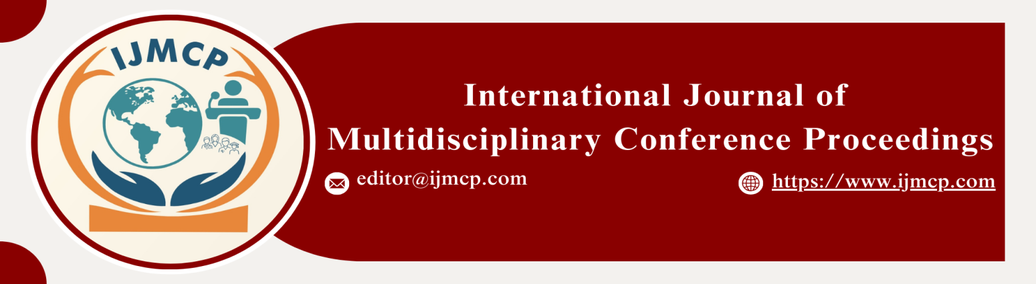

**Impact of Social media usage and Stress levels on Student mental health mediations Role of sleep quality**

1stSidra Bibi, 2ndMaryam Yousaf, 3rdMuqadas Yaseen & 4thSadaf Muneer

1st Scholar, Department of sociology, Thal University Bhakkar

2nd Scholar, Department of sociology, Thal University Bhakkar

3rd Scholar, Department of sociology, Thal University Bhakkar

4th Scholar, Department of sociology, Thal University Bhakkar

|  |  |
| --- | --- |
| **KEYWORDS** | **ABSTRACT** |
| Social Media Usage, Stress Levels, Sleeping Quality, Awareness Social Networks, Anxiety, Job Stress | The primary objective of this research is to examine the relationship between social media usage and student mental health. Moreover, the purpose of this study is to examine the role of stress levels on student mental health. Furthermore, the objective is to examine the mediating role of sleep quality in the relationship between stress levels and student mental health. The current study employs a quantitative research design. Researchers follow a positivist research philosophy. Our population is known, so researchers used simple random sampling. The population for this current research is constant in Thal University Bhakkar. The sample size of 300 participants is required for adequate statistical power. Researchers used SPSS and Smart PLS-SEM for data analysis. The current study findings show that there is a significant role of social media usage on student mental health. Furthermore, the findings show that stress levels are a stronger predictor of student mental health than social media usage. Lastly, the findings show that there is a significant mediating role of sleep quality in the relationship between stress levels and student mental health. |
| **ARTICLE HISTORY** |
| Date of Submission: 22-11-2024  Date of Acceptance: 28-11-2024  Date of Publication: 30-12-2024 |
| **Conference Organizer(s)** |
| Research Consultancy on Social & Management Development  &  Thal University Bhakkar |
| Corresponding Email |  |
| Volume-Issue-Page Number | 1(*1*) 14 |
| Citation | Bibi, S., Yousaf, M., Yaseen, M., & Muneer, S. (2024). Impact of social media usage and stress levels on student mental health: Mediation role of sleep quality. *Proceedings of the 1st International Conference on Innovation and Sustainability in Management and Social Sciences, International Journal of Multidisciplinary Conference Proceedings, 1(1).* |