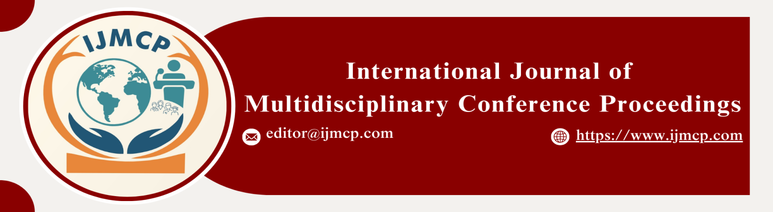

**Impact of Smog on Human Health**

1stManzoor Hussain, 2ndSabir Hussain, 3rdQasim Ali & 4thNuman Ali

1st Department of sociology and criminology, university of Sargodha, Sargodha

2nd Department of sociology and criminology, university of Sargodha, Sargodha

3rd Department of sociology and criminology, university of Sargodha, Sargodha

4th Department of sociology and criminology, university of Sargodha, Sargodha

|  |  |
| --- | --- |
| **KEYWORDS** | **ABSTRACT** |
| Smog, Cardiovascular Diseases, Health. | The objective of this study is to explore the relationship between smog and human health. Specifically, the study aims to investigate the impact of smog on respiratory health. Examine the relationship between smog exposure and cardiovascular diseases. This study employed a quantitative research approach, using a questionnaire to collect data from 100 participants. The questionnaire was designed to gather information about the participants’ environmental knowledge, daily experience, and health-related problems due to smog. The data were analyzed using SPSS software. The correlation test was used to examine the relationship between smog exposure and respiratory health. The results showed a significant positive correlation between smog exposure and respiratory problems (r = 0.456, p < 0.01). The regression model test was used to examine the relationship between smog exposure and cardiovascular diseases. The results showed that smog exposure is a significant predictor of cardiovascular diseases (β = 0.321, p < 0.01), accounting for 10.3% of the variance. |
| **ARTICLE HISTORY** |
| Date of Submission: 24-11-2024  Date of Acceptance: 29-11-2024  Date of Publication: 30-12-2024 |
| **Conference Organizer(s)** |
| Research Consultancy on Social & Management Development  &  Thal University Bhakkar |
| Corresponding Email | mmhhkaali1234567@gmail.com |
| Volume-Issue-Page Number | 1(*1*) 12 |
| Citation | Hussain, M., Hussain, S., Ali, Q., & Ali, N. (2024). Impact of smog on human health. *Proceedings of the 1st International Conference on Innovation and Sustainability in Management and Social Sciences, International Journal of Multidisciplinary Conference Proceedings, 1(1).* |