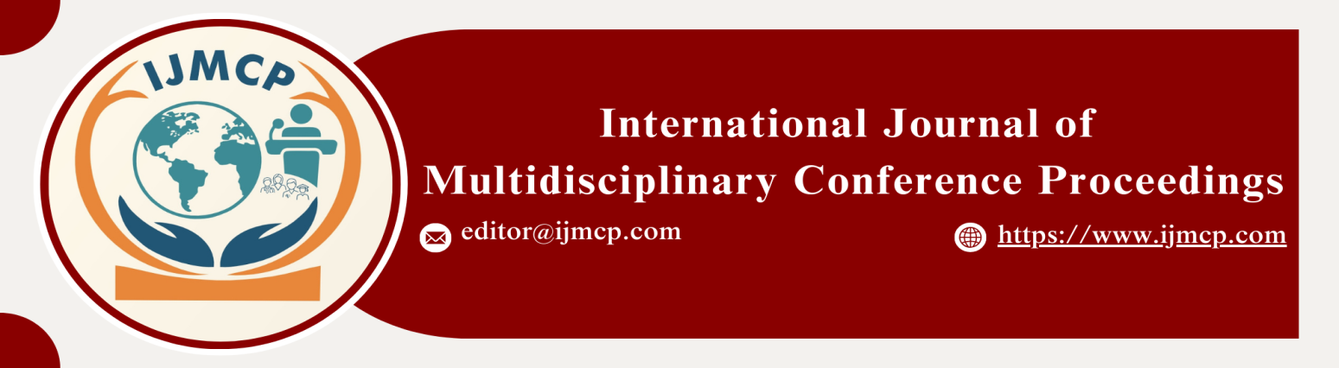

**Divorce and Remarriage in Pakistani society, social acceptance and challenges**

1stMuneeb Ahsan, 2ndShoaib Ul Hassan, 3rdSoban Tariq, 4thSadia Mussrat, 5thAlisha Sameem, 6thMoeen Hamza

Scholars, Thal University Bhakkar

|  |  |
| --- | --- |
| **KEYWORDS** | **ABSTRACT** |
| Divorce, Remarriage, Dissolution Of Marriage. | Divorce is the legal dissolution of marriage. In Pakistan, the dissolution of marriage is considered a taboo, and being divorced is regarded as a stigma. The aim and objective of this study is to examine the social attitudes surrounding divorce and remarriage. This quantitative study was conducted using a descriptive survey research design. A stratified random sample of 100 men and 100 women of all ages in District Bhakkar was selected. Data were gathered using a structured questionnaire. The study findings disclose that divorced women face various challenges such as labeling, judgment, character assassination, and social stigma. The study also reveals that men do not face any kind of significant problems regarding remarriage; they remarry easily, and society generally accepts their second marriage without any major objections. On the other hand, remarriage for women is more complicated and challenging. We must shift the perception of divorce and remarriage from shame to recognition of rights. It is recommended that the shame and stigma attached to divorce should be reduced and that men and women be granted equal rights regarding their remarriage. |
| **ARTICLE HISTORY** |
| Date of Submission: 23-11-2024  Date of Acceptance: 28-11-2024  Date of Publication: 30-12-2024 |
| **Conference Organizer(s)** |
| Research Consultancy on Social & Management Development  &  Thal University Bhakkar |
| Corresponding Email |  |
| Volume-Issue-Page Number | 1(*1*) 11 |
| Citation | Ahsan, M., Hassan, S. U., Tariq, S., Mussrat, S., Sameem, A., & Hamza, M. (2024). Divorce and remarriage in Pakistani society: Social acceptance and challenges. *Proceedings of the 1st International Conference on Innovation and Sustainability in Management and Social Sciences, International Journal of Multidisciplinary Conference Proceedings, 1(1).* |