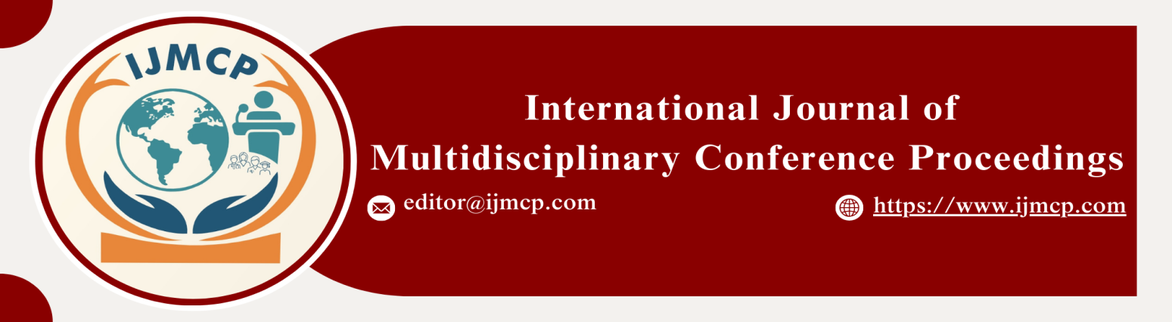

**The Impact of Social Media Bullying on Personality Development among University Students**

1stMuqadas Yasin

1st Department of Sociology Thal University Bhakkar

|  |  |
| --- | --- |
| **KEYWORDS** | **ABSTRACT** |
| Personality Development, Social Media Bullying, Self-Esteem, Self-Image, Emotional Intelligence | This abstract explores the phenomenon of social media bullying and its potential impact on the personality development of university students. Personality development refers to the psychological, emotional, and social changes that occur during this critical period in an individual's life. The research aims to investigate how social media bullying influences key aspects of personality development, including self-esteem, self-image, self-efficacy, and interpersonal relationships. The research was conducted using an online survey questionnaire, which was distributed to 100 university students. The data collected from the survey were analyzed using the Statistical Package for the Social Sciences (SPSS). Descriptive and inferential statistics, including mean, frequency, percentage, correlation, and ANOVA, were employed to assess the impact of social media bullying on personality development. The findings revealed a significant correlation between social media bullying and negative effects on students' self-esteem and self-image. Additionally, bullying was found to influence students' interpersonal relationships and emotional well-being, highlighting the damaging impact of such experiences on their overall personality development. In conclusion, social media bullying can significantly affect the personality development of university students, with implications for their emotional intelligence, self-concept, and coping mechanisms. The study emphasizes the need for addressing these negative behaviors in the digital space to promote healthier interactions among young adults. |
| **ARTICLE HISTORY** |
| Date of Submission: 22-11-2024  Date of Acceptance: 29-11-2024  Date of Publication: 30-12-2024 |
| **Conference Organizer(s)** |
| Research Consultancy on Social & Management Development  &  Thal University Bhakkar |
| Corresponding Email |  |
| Volume-Issue-Page Number | 1(*1*) 5 |
| Citation | Yasin, M. (2024). The impact of social media bullying on personality development among university students. *Proceedings of the 1st International Conference on Innovation and Sustainability in Management and Social Sciences, International Journal of Multidisciplinary Conference Proceedings, 1(1).* |