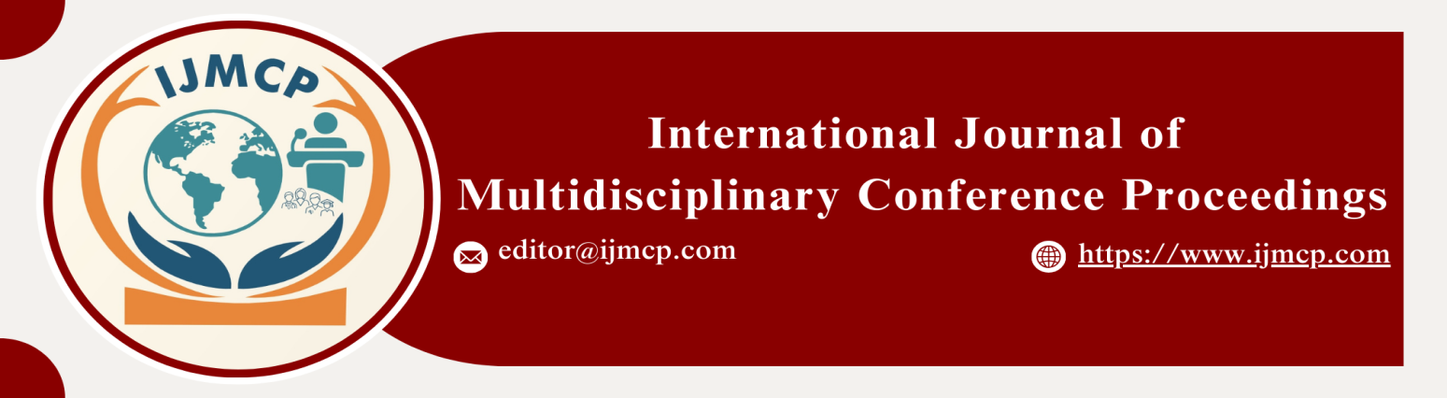

**Effect of Leadership Style & Customer Orientation on Marketing Innovation Mediating Role of Employee Empowerment & Moderating Role of Organizational Culture**

1stMazhar Abbas, 2ndMuhammad Jameel, & 3rdMuhammad Umair

1st Research Scholar, Department of Commerce, Thal University Bhakkar

2nd Research Scholar, Department of Commerce, Thal University Bhakkar

3rd Research Scholar, Department of Commerce, Thal University Bhakkar

|  |  |
| --- | --- |
| **KEYWORDS** | **ABSTRACT** |
| Leadership Style, Customer Orientation, Marketing Innovation, Employee Empowerment. | The main purpose of this research is to investigate the effect of Leadership style on Marketing Innovation. Furthermore, the objective is also to examine the effect of Customer orientation on Marketing Innovation. Moreover, the study investigates the mediating role of Employee Empowerment between Leadership style, Customer orientation, and Marketing Innovation. Lastly, the study examines the moderating role of Organizational Culture between Leadership style, Customer orientation, and Marketing Innovation. The current research design is quantitative in nature, grounded in a positivist philosophy. The population for this study was not specified. The sample size of the current study is 300 respondents. The findings of the current research indicated that there is a significant effect of Leadership style on Marketing innovation. Furthermore, the findings also indicated a significant effect of Customer orientation on Marketing innovation. Moreover, the findings revealed a significant mediating role of Employee Empowerment between Leadership style, Customer orientation, and Marketing Innovation. Lastly, the findings indicated a significant moderating role of Organizational Culture between Leadership style, Customer orientation, and Marketing Innovation. |
| **ARTICLE HISTORY** |
| Date of Submission: 22-11-2024  Date of Acceptance: 27-11-2024  Date of Publication: 30-12-2024 |
| **Conference Organizer(s)** |
| Research Consultancy on Social & Management Development  &  Thal University Bhakkar |
| Corresponding Email |  |
| Volume-Issue-Page Number | 1(*1*) 21 |
| Citation | Abbas, M., Jameel, M., & Umair, M. (2024). The effect of leadership style and customer orientation on marketing innovation: The mediating role of employee empowerment and the moderating role of organizational culture. *Proceedings of the 1st International Conference on Innovation and Sustainability in Management and Social Sciences, International Journal of Multidisciplinary Conference Proceedings, 1(1).* |