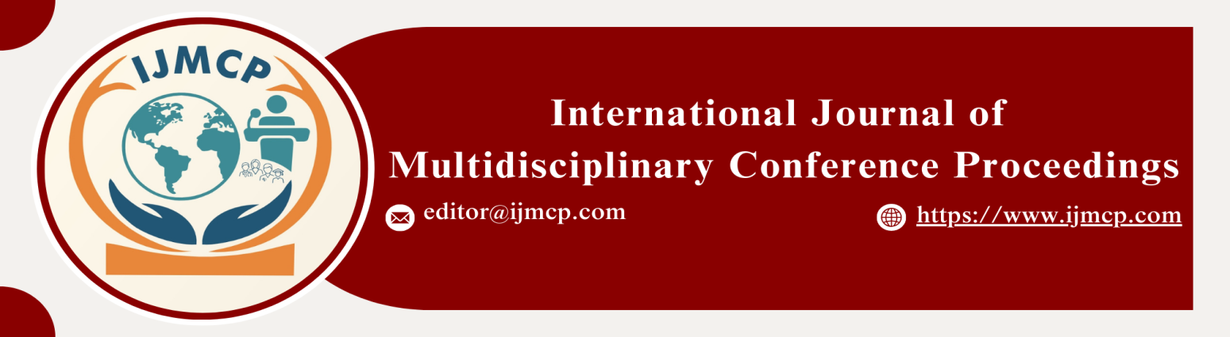

**The Impact of Leadership Style, Employee Engagement, and Organizational Culture on Job Performance**

1stMuhammad Hussnain, 2ndZoya Sajid, & 3rdMaryam Ramzan

1st Lecturer in Management Sciences GCUF Sahiwal Campus

2nd Research Scholar in Management sciences GCUF Sahiwal Campus

3rd Research Scholar in Management sciences GCUF Sahiwal Campus

|  |  |
| --- | --- |
| **KEYWORDS** | **ABSTRACT** |
| Leadership Style, Employee Engagement, Organizational Culture, Job Performance, Workforce Productivity | This study examines how leadership style, employee engagement, and organizational culture influence job performance in dynamic and competitive work environments. A quantitative research design was employed to investigate the relationships among these factors. Data were collected from 350 employees working in various industries through a structured survey questionnaire. The analysis was conducted using multiple regression techniques and structural equation modeling (SEM) to assess the interactions and direct effects of the variables. The results reveal that transformational leadership has a significant positive impact on job performance. Furthermore, organizational culture, characterized by inclusivity, shared values, and adaptability, strengthens the link between leadership style and employee output. Together, these factors account for 75% of the variance in job performance. The findings suggest that organizations should adopt transformational leadership practices that empower and motivate employees. These efforts can lead to improved job performance, reduced turnover rates, and overall organizational success. The study provides actionable insights for managers and human resource professionals. |
| **ARTICLE HISTORY** |
| Date of Submission: 24-11-2024  Date of Acceptance: 28-11-2024  Date of Publication: 30-12-2024 |
| **Conference Organizer(s)** |
| Research Consultancy on Social & Management Development  &  Thal University Bhakkar |
| Corresponding Email | m.hasnainali270@gmail.com |
| Volume-Issue-Page Number | 1(*1*) 17 |
| Citation | Hussnain, M., Sajid, Z., & Ramzan, M. (2024). The impact of leadership style, employee engagement, and organizational culture on job performance. *Proceedings of the 1st International Conference on Innovation and Sustainability in Management and Social Sciences, International Journal of Multidisciplinary Conference Proceedings, 1(1).* |