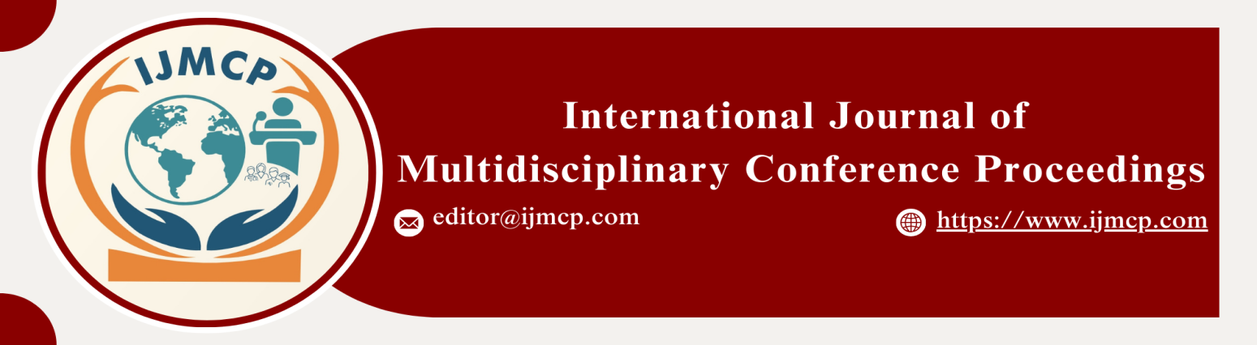

**Effect of extracurricular participation and academic pressure on students burnout with coping strategies as a mediator**

1stRimsha Shamshad

1st Scholar, Department of Sociology, Thal University Bhakkar

|  |  |
| --- | --- |
| **KEYWORDS** | **ABSTRACT** |
| Extracurricular Participation, Academic Pressure, Student Burnout, Coping Strategies, Mediating | This study aims to explore the impact of extracurricular participation and academic pressure on student burnout, with a particular focus on the mediating role of coping strategies. Furthermore, the study seeks to examine whether coping strategies can mediate the relationship. The study employs a quantitative research design, grounded in a positivist philosophy, which emphasizes objective measurement and statistical analysis. A deductive approach is used to test hypotheses based on existing theories. The research population consists of students from Thal University Bhakkar, with a total population of 6,000 students. A sample of 300 students was selected using a simple random sampling technique to ensure representativeness and reduce bias. Data were collected using structured survey questionnaires, and the analysis was carried out using SPSS and Smart PLS SEM for data processing and modeling. Firstly, extracurricular participation can have a complex impact on student burnout. While moderate levels of participation may offer benefits. Secondly, academic pressure is found to have a strong impact on student burnout. Lastly, the study indicates that coping strategies significantly mediate the relationship between both extracurricular participation and academic pressure on student burnout. This study provides valuable insights into the role of coping strategies in reducing burnout, offering practical implications for educators and institutions in developing strategies to support students and enhance their well-being. |
| **ARTICLE HISTORY** |
| Date of Submission: 22-11-2024  Date of Acceptance: 27-11-2024  Date of Publication: 30-12-2024 |
| **Conference Organizer(s)** |
| Research Consultancy on Social & Management Development  &  Thal University Bhakkar |
| Corresponding Email |  |
| Volume-Issue-Page Number | 1(*1*) 18 |
| Citation | Shamshad, R. (2024). Effect of extracurricular participation and academic pressure on students' burnout with coping strategies as a mediator. *Proceedings of the 1st International Conference on Innovation and Sustainability in Management and Social Sciences, International Journal of Multidisciplinary Conference Proceedings, 1(1).* |