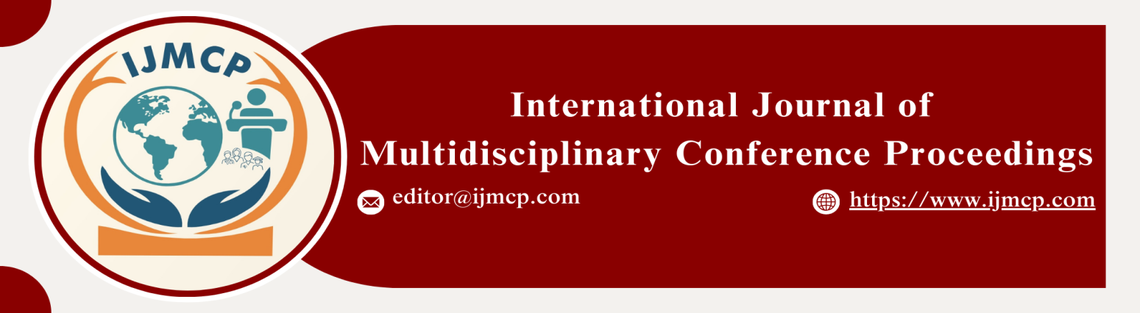

**Role of Dividend Payout, Retained Earnings, and Market Conditions in Firm Reputation**

1stMuhammad Hasnain Ali, 2ndMuhammad Abdullah, & 3rdShan Ali

1st PHD Scholar, BZU Multan

2nd Research Scholar, Department of Commerce, University of Sahiwal

3rd Research Scholar , Department of Commerce, University of Sahiwal

|  |  |
| --- | --- |
| **KEYWORDS** | **ABSTRACT** |
| Dividend Payout, Retained Earnings, Market Conditions, Firm Reputation, Corporate Performance | This study explores the influence of dividend payout, retained earnings, and market conditions on firm reputation, a critical intangible asset that significantly impacts stakeholder trust and investment decisions. Dividend payout is examined as a measure of shareholder value distribution, while retained earnings reflect a firm's internal growth strategies. Market conditions act as an external factor influencing public perception and corporate performance. This study employs a quantitative research design using secondary data from publicly traded companies spanning five years. Structural Equation Modeling (SEM) is employed for data analysis to determine the relationships between variables and their statistical significance. The results reveal that dividend payout has a positive and significant impact on firm reputation. Retained earnings show a dual effect, with higher reserves signaling stability and growth but sometimes raising concerns about insufficient shareholder returns. Market conditions moderate these relationships. Companies must balance dividend payouts and retained earnings to maintain investor trust and fund growth initiatives. Additionally, firms should remain agile in adapting to fluctuating market conditions to safeguard their reputations. These insights offer valuable guidance for financial managers, policymakers, and investors aiming to optimize firm reputation as a competitive advantage. |
| **ARTICLE HISTORY** |
| Date of Submission: 23-11-2024  Date of Acceptance: 28-11-2024  Date of Publication: 30-12-2024 |
| **Conference Organizer(s)** |
| Research Consultancy on Social & Management Development  &  Thal University Bhakkar |
| Corresponding Email | mabdullah040swl@gmail.com |
| Volume-Issue-Page Number | 1(*1*) 19 |
| Citation | Ali, M. H., Abdullah, M., & Ali, S. (2024). Role of dividend payout, retained earnings, and market conditions in firm reputation. *Proceedings of the 1st International Conference on Innovation and Sustainability in Management and Social Sciences, International Journal of Multidisciplinary Conference Proceedings, 1(1).* |