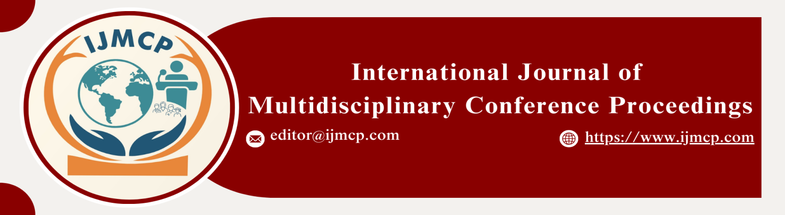

**The effect of workplace stress on escalating depression crisis**

1stRana Muhammad Shayan

1st Department of Sociology and Criminology

|  |  |
| --- | --- |
| **KEYWORDS** | **ABSTRACT** |
| Workplace, Stress, Depression, Job Demands, Work Life Balance, Organizational Culture. | Workplace stress has become an increasingly prevalent issue in modern work environments, and its impact on mental health, particularly depression, is a growing concern. Factors like high job demands, lack of support, poor work-life balance, and organizational culture are identified as key factors that trigger or worsen depression among employees. In this regard, the current study was conducted using a quantitative research design. By using a stratified sampling technique, data were collected through a questionnaire. Data were taken from 102 university students who have access to social media. The study results were analyzed using SPSS software, and the descriptive section indicates that the majority of respondents were in the 21-30 age group and included both males and females. Furthermore, when the inferential statistical tests, regression and correlation, were used, the results revealed that workplace stress had a significant and strong positive effect on depression. It also calls for workplace interventions, such as stress management programs, employee mental health resources, and organizational policy reforms, to mitigate the harmful effects of stress and promote mental well-being in the workforce. |
| **ARTICLE HISTORY** |
| Date of Submission: 23-11-2024  Date of Acceptance: 28-11-2024  Date of Publication: 30-12-2024 |
| **Conference Organizer(s)** |
| Research Consultancy on Social & Management Development  &  Thal University Bhakkar |
| Corresponding Email | aslamshayan20@gmail.com |
| Volume-Issue-Page Number | 1(*1*) 15 |
| Citation | Shayan, R. M. (2024). The effect of workplace stress on escalating depression crisis. *Proceedings of the 1st International Conference on Innovation and Sustainability in Management and Social Sciences, International Journal of Multidisciplinary Conference Proceedings, 1(1).* |